Solution 1: Three IDCs with three replicas in the same region
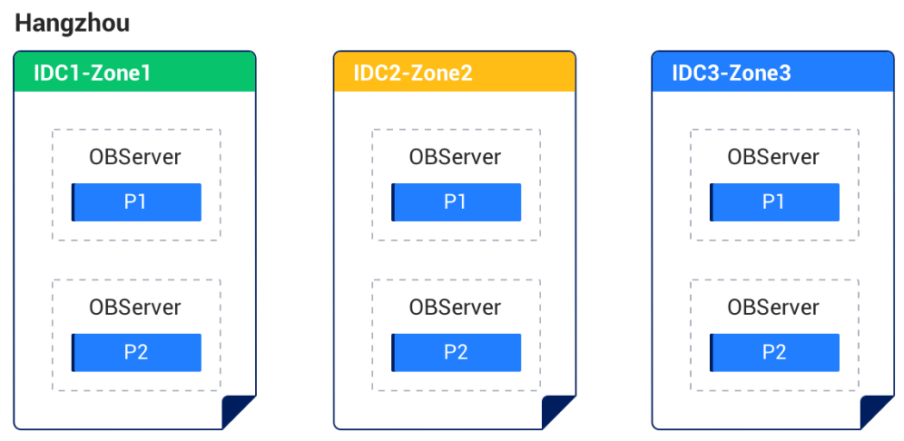

Solution 2: Five IDCs with five replicas across three regions
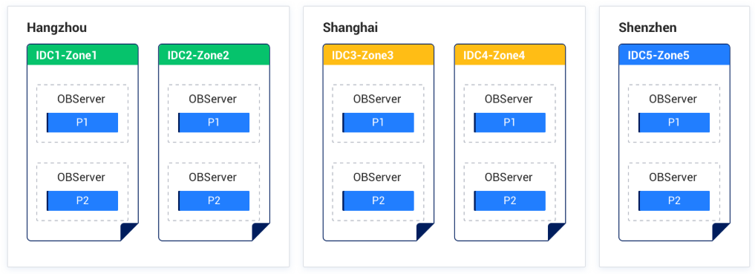

Solution 3: Primary-standby deployment of two IDCs in the same region
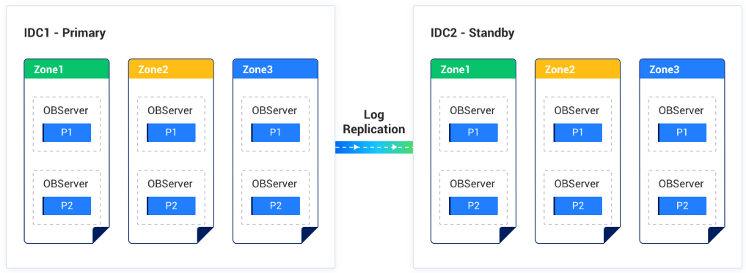

Solution 4: Primary-standby deployment of three IDCs across two regions
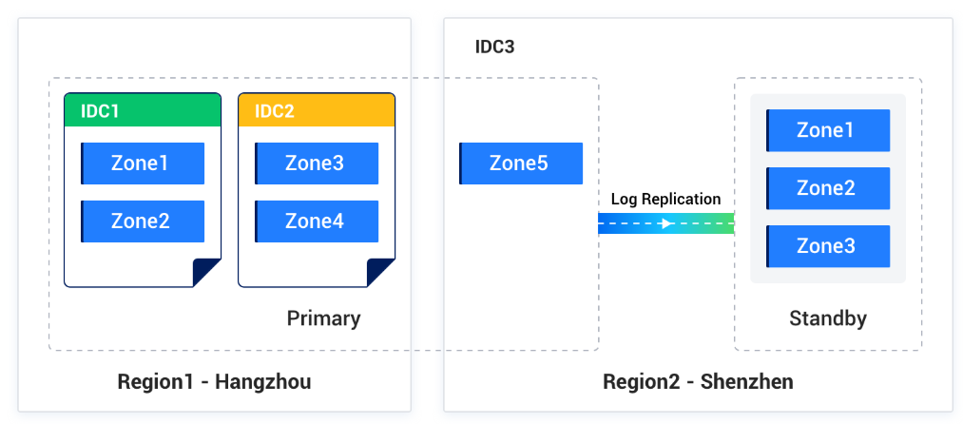

Solution 5: Three IDCs in the same region with the arbitration service
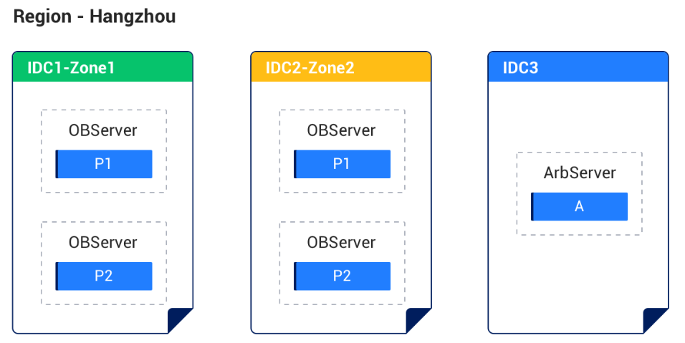

Solution 6: Five IDCs across three regions with the arbitration service
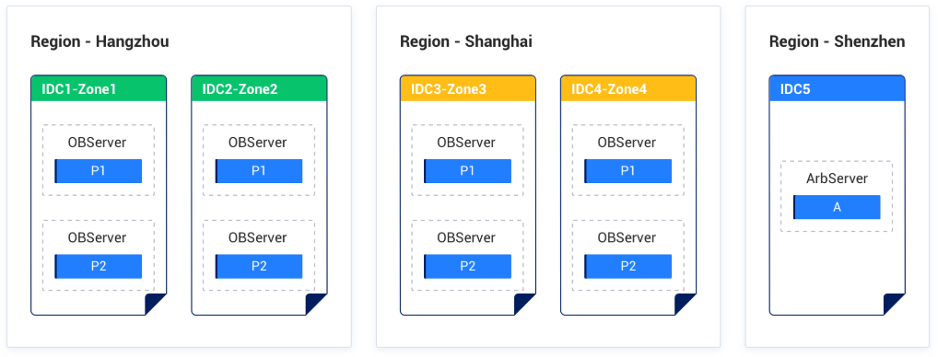

Solution 7: Three IDCs across two regions with the arbitration service


